LAB REPORT实验报告
Lab Title | Interactive Input and Selections |  |  |  | Lab No. | 02
Stud. Name | Jiang Yunxiang | Major | CST |  | Class
Student ID | 2022102330 |  | Date | 2023/3/3
Lab description/objectives:
Learn Interactive Input and Selections
Source code:
#include <stdio.h>

int main()
{
int year = 0;
float weight = 0;
printf("Please enter the year of your automobile\n");
scanf("%d", &year);
printf("Please enter the weight(lbs) of your automobile\n");
scanf("%f", &weight);
if (year <= 1970 && weight <= 2700)
printf("Your car's weight class is 1 and the registration fee for it is 16.50$");
else if (year <= 1970 && 2700 < weight && weight <= 3800)
printf("Your car's weight class is 2 and the registration fee for it is 25.50$");
else if (year <= 1970 && weight > 3800)
printf("Your car's weight class is 3 and the registration fee for it is 46.50$");
else if (1971 <= year <= 1979 && weight <= 2700)
printf("Your car's weight class is 4 and the registration fee for it is 27.00$");
else if (1971 <= year <= 1979 && 2700 < weight && weight <= 3800)
printf("Your car's weight class is 5 and the registration fee for it is 30.50$");
else if (1971 <= year <= 1979 && weight > 3800)
printf("Your car's weight class is 6 and the registration fee for it is 52.50$");
else if (year >= 1980 && weight <= 3500)
printf("Your car's weight class is 7 and the registration fee for it is 35.50$");
else if(year >= 1980 && weight > 3500)
printf("Your car's weight class is 8 and the registration fee for it is 65.50$");
return 0;
}
Program outputs:
（Paste the screenshot of program output here）
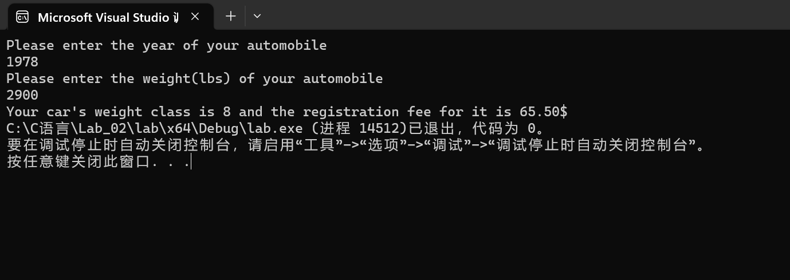
Discussion:
1．Most difficult parts
（What were the most difficult parts of your program to implement?）
How to simplify the code and how to make it clear and beautiful.
2．Bugs and/or Errors
(List all the program bugs/errors you encountered and how you corrected them.)
Nope

